3/31/24, 3:17 PM Untitled4

Program 7 : Write a prgram to demonstrate Linear Regression

In [1]:

**import** numpy **as** np

**import** matplotlib.pyplot **as** plt

**from** sklearn.linear_model **import** LinearRegression

*# Generate some random data*

np**.**random**.**seed(0)

X **=** 2 **\*** np**.**random**.**rand(100, 1)

y **=** 3 **\*** X **+** np**.**random**.**randn(100, 1)

*# Instantiate and fit the linear regression model*

model **=** LinearRegression() model**.**fit(X, y)

*# Make predictions*

X_new **=** np**.**array([[0], [2]]) y_pred **=** model**.**predict(X_new)

*# Plot the data and the linear regression line*

plt**.**scatter(X, y)

plt**.**plot(X_new, y_pred, color**=**'red') plt**.**xlabel('X')

plt**.**ylabel('y')

plt**.**title('Linear Regression') plt**.**show()

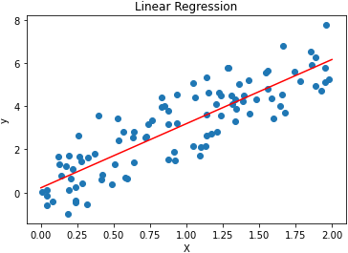

file:///C:/Users/ACER/Downloads/Untitled4 (2).html 1/1